Laboratory exercise 11
Task 1
Add controls for changing colors and font size. Using JS, create a way for a text container to be selected and set the background color, text color, and font size. Test the input, change, and click events.
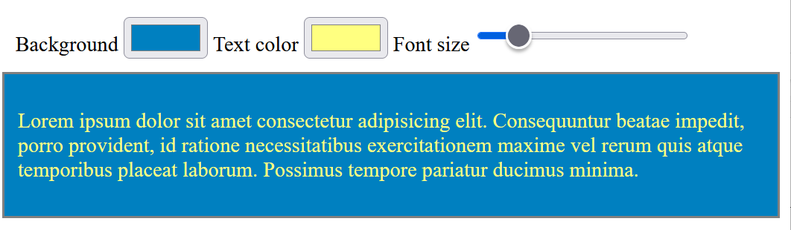
Task 2
Add an input field and a paragraph containing the text "Characters entered: X". Using JS, make the number of characters count dynamically as they are entered and reflect the number in the paragraph. Test the input, change, and keyup events.
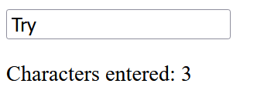
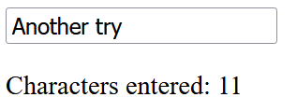
Task 3
Copy the source code for the task below. Using JavaScript, create a function that allows you to filter the displayed list. When a sequence of characters is entered from the keyboard, only those list items should be displayed:
- which contain them;
- which begin with them.
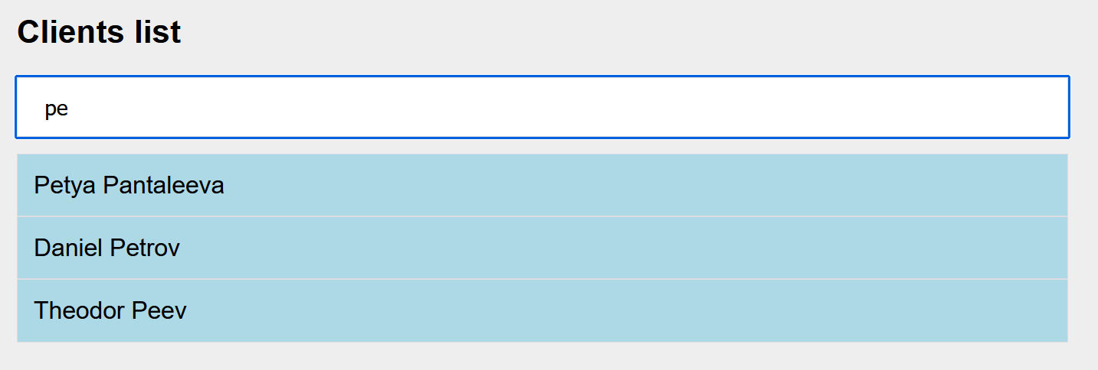
<!DOCTYPE html>
<html>

<head>
<meta charset="utf-8">
<style>
* {
box-sizing: border-box;
}

body {
font-family: arial, sans-serif;
}

.content {
width: 80%;
margin: 0 auto;
background-color: #eee;
padding: 40px;
}

#input {
width: 100%;
font-size: 16px;
padding: 12px 20px;
border: 1px solid #ddd;
margin-bottom: 12px;
}

ul {
list-style-type: none;
padding: 0;
margin: 0;
}

li {
border: 1px solid #ddd;
background-color: lightblue;
padding: 12px;
font-size: 18px;
color: black;
display: block;
}
</style>
</head>

<body>
<div class="content">
<h2>Clients list</h2>
<input type="text" id="input" placeholder="Search">

<ul id="list">
<li>Petya Pantaleeva</li>
<li>Orlin Antonov</li>
<li>Alexander Ivanov</li>
<li>Found Alekseev</li>
<li>Vasil Ivanchev</li>
<li>Stanislava Stoyanova</li>
<li>Georgi Panchev</li>
<li>Daniel Petrov</li>
<li>Kyril Alexandrov</li>
<li>Rositsa Kirilova</li>
<li>Alexandra Koleva</li>
<li>Theodor Peev</li>
<li>Hristo Alexiev</li>
<li>Alexander Stoyanov</li>
</ul>
</div>
<script>

</script>

</body>

</html>
Task 4
Create controls that allow you to enter the number of rows and columns in a table. When the button is pressed, a similar table will be created on the page with the content "Header" in the header cells and "Cell" in the data cells.

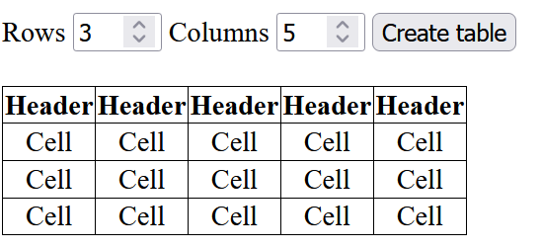

Task 5
Create the following controls:
• Input field for URL address (for example: https://google.com)
• Input field for link text (for example: "Google")
• "Add link" button
You need an empty <div id="links"></div>, in which the links will be added.
When the button is clicked, a new HTML hyperlink element should be created. Its href should be the value from the first field. Its text should be the value from the second field. It should open in a new tab (target="_blank"). The link should be added inside <div id="links">.
If any field is empty, DO NOT create a link and display a message in <p id="error">.
Visualization:
- After pressing the button with an empty field
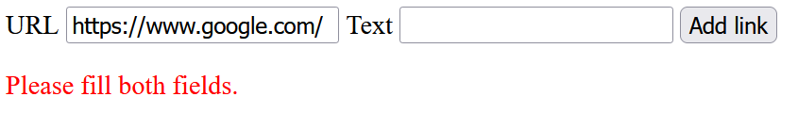
- After pressing the button with all fields filled in
